UML Design Diagram

Project Title: Library Management System (LMS)
Project Type: Full-stack Web Development Capstone Project
Document Version: 1.0
Author: Kelvin Wong
Date: 09 December 2025

Summary
Below shows the UML diagram for Library Management System using both mermaidchart codes and visual diagram

Feature Diagram

Login & Role Flow (Mermaid Flowchart)

flowchart TD

A[User] --> B[Logon Screen]
B --> C[Login or Create Account]
C --> D{Login Success?}
D -->|No| E[Show Error]

D -->|Yes| F{User Role}
F -->|Admin| G[Admin Dashboard]

F -->|Member| H{Member Status}

H -->|Suspended| X[Cannot Login]
H -->|Expired| Y[Must Renew Before Login]
H -->|Expires ≤ 60 Days| Z[Warn User]
H -->|OK| M[Member Dashboard]
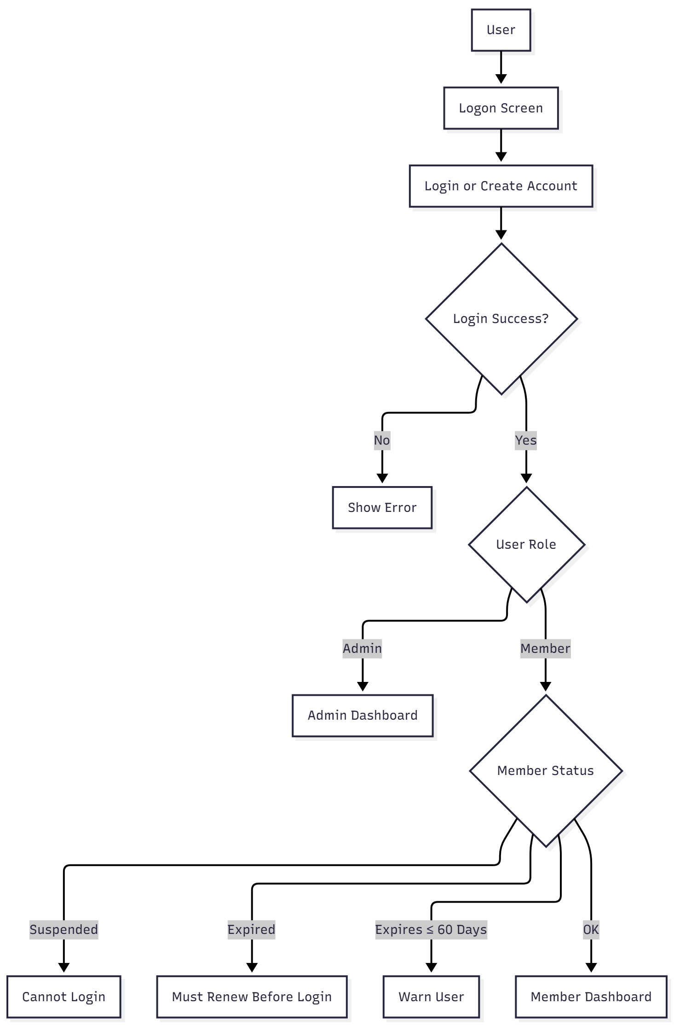

Member Dashboard Features

flowchart TD

M[Member Dashboard] --> ML[My Loans]
M --> MR[My Reservations]

ML --> B1[Borrow Books]
B1 --> B2{Borrow ≤ 3?}
B1 --> B3{Fines < $10?}
B1 --> B4{Fine ≤ $20/book?}

ML --> MS[Manage Status]
MS --> R1[Return Books]
MS --> R2[Pay Fines]
MS --> R3[Renew ≤ 2 Times]

ML --> VH[View Loan History]

MR --> Rsv1[Make Reservations]
Rsv1 --> Rsv2{Reserve ≤ 3?}

MR --> RsvM[Manage Reservations]
RsvM --> RsvC[Cancel Reservation]

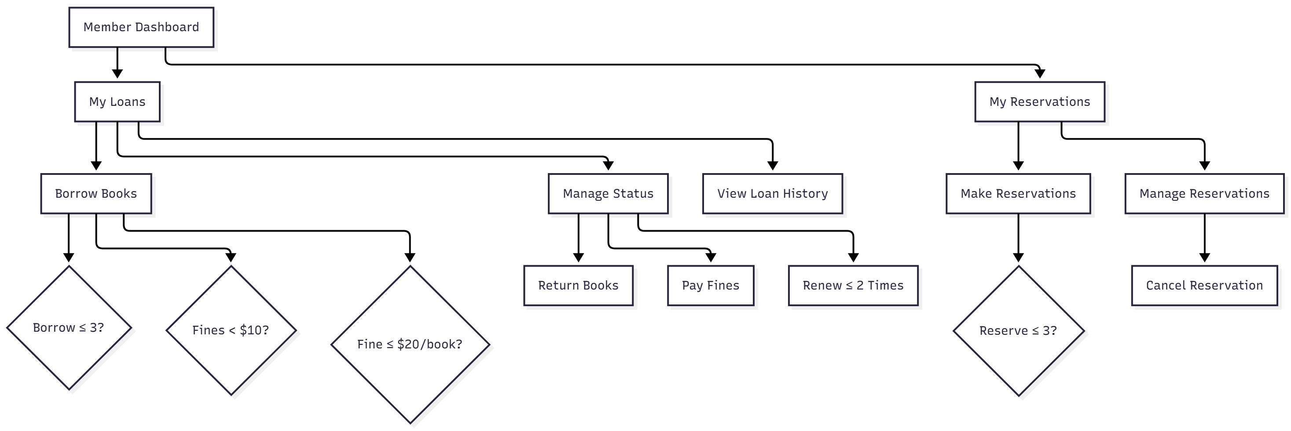

Admin Dashboard Features

flowchart TD

G[Admin Dashboard] --> U1[Manage Users - CRUD]
G --> Bk1[Manage Books - CRUD]
G --> AL[Active Loans]
AL --> AL1[Renew on Behalf of Member]
AL --> AL2[Return on Behalf of Member]

G --> LH[Loan History]

G --> AR[All Reservations]
AR --> ARC[Cancel Reservations]
AR --> ARF[Set Fulfilled]

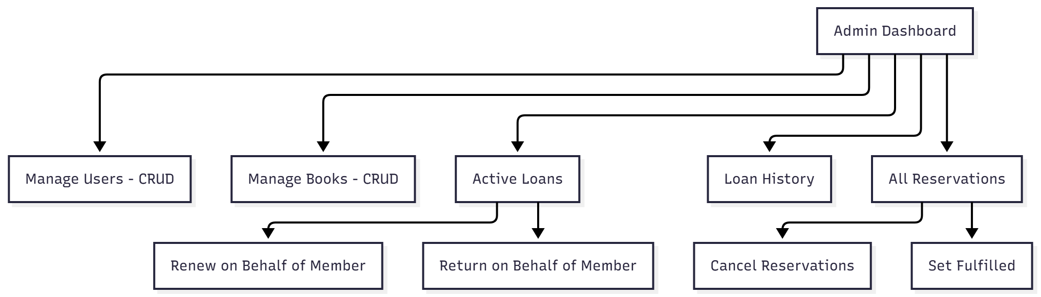

Common Functions (All Users)

flowchart TD

User --> C1[User Profile]
User --> C2[Logout]

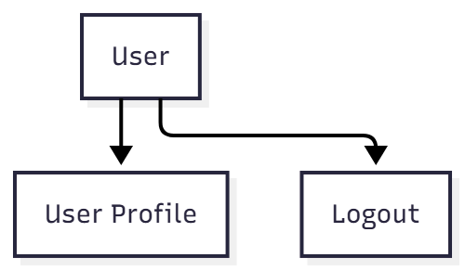

Class Diagram

classDiagram

%% =========================
%% USER CLASSES
%% =========================

class User {
+userId : String
+name : String
+email : String
+passwordHash : String
+role : UserRole
+status : MemberStatus
+membershipExpiry : Date
+login()
+updateProfile()
}

class Admin {
}

class Member {
+borrowCount : int
+reservationCount : int
+cumulativeFines : decimal
+canBorrow() bool
+canReserve() bool
+renewMembership()
}

User <|-- Admin
User <|-- Member

%% =========================
%% ENUMS
%% =========================

class UserRole {
<<enumeration>>
ADMIN
MEMBER
}

class MemberStatus {
<<enumeration>>
ACTIVE
SUSPENDED
EXPIRED
}

class BookStatus {
<<enumeration>>
AVAILABLE
BORROWED
RESERVED
}

class ReservationStatus {
<<enumeration>>
ACTIVE
CANCELLED
FULFILLED
}

%% =========================
%% BOOK CLASSES
%% =========================

class Book {
+bookId : String
+title : String
+author : String
+category : String
+status : BookStatus
}

%% =========================
%% LOANS
%% =========================

class Loan {
+loanId : String
+borrowDate : Date
+dueDate : Date
+returnDate : Date
+renewCount : int
+renew()
+returnBook()
+calculateFine()
}

Member --> Loan : "borrows 0..3"
Book --> Loan : "is loaned in 0..1"

%% =========================
%% RESERVATIONS
%% =========================

class Reservation {
+reservationId : String
+reservationDate : Date
+status : ReservationStatus
+cancel()
+fulfill()
}

Member --> Reservation : "makes 0..3"
Book --> Reservation : "is reserved by 0..*"

%% =========================
%% FINES
%% =========================

class Fine {
+fineId : String
+amount : decimal
+reason : String
+dateIssued : Date
+paid : bool
+pay()
}

Loan --> Fine : "generates 0..*"
Member --> Fine : "owes 0..*"

